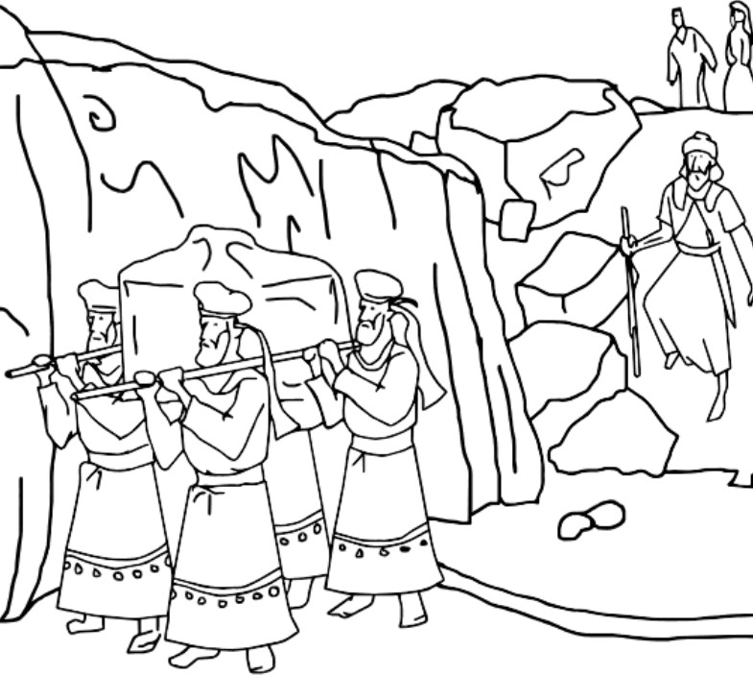
God stopped the river.
Cgynyt can. Al Free churchor
God Stopped the

River Colouring Page

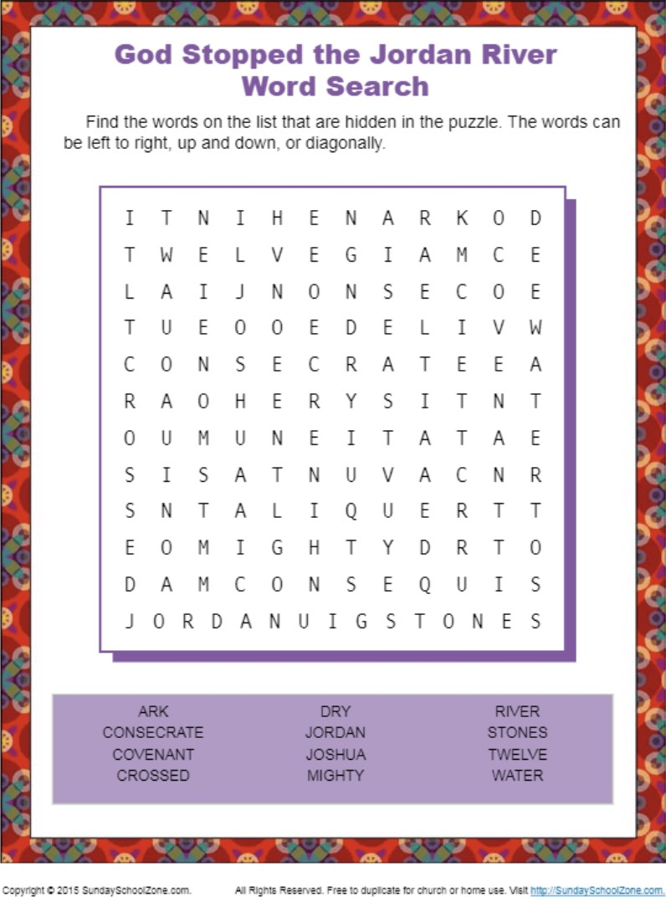

God Stopped the Jordan River Spot the Differences
Compare the picture on the top with the picture on bottom. Circle the 13 things that are different.
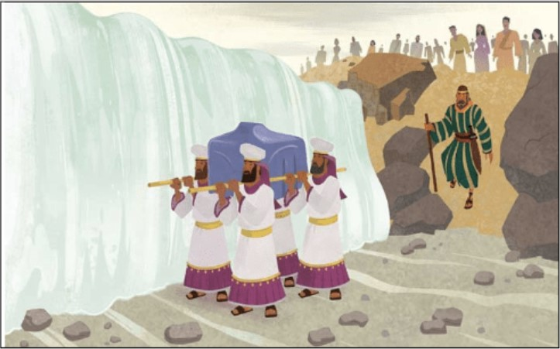
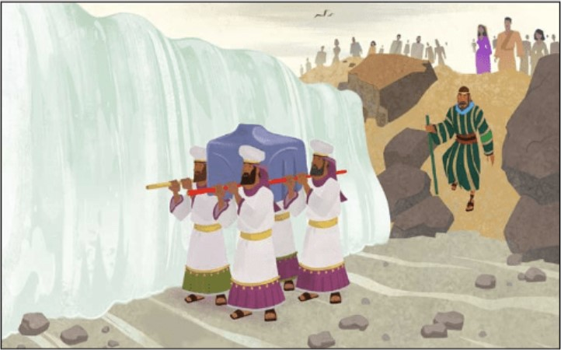
God Stopped the Jordan River Spot the Differences

